# Door/Window Sensors

## Summary

| Item | Description |
| --- | --- |
| Device: Purpose | Detect door/window open state. When door/window closes, respective switch closes and completes its circuit. |
| Device: Proteus Library component name | (No Proteus Name) ECE298_GEN_SWITCH. |
| Device: Project Operating Range Requirement | Switch is binary, detects contact between swinging edge of door/window and door/window frame. |
| Device: Power Connections | Switch uses two connections: one 3.3V IN (power) and one GND (routed back to MCU). |
| Device: Electrical signal type properties | Device receives constant power as input. The output is a digital signal to be interpreted as a closed or open state. |
| Device: Electrical signal range (voltage, or current, resistance, capacitance or time etc.) | Resistance is either 0.01 Ohms closed or infinite open. Outputted voltage is either 3.3 or 0 Volts. Details on VIH, MAX and VIL, MIN are unavailable for this component. |
| MCU connectivity details | Output of switch will use MCU digital input ports. Switch input will use MCU 3.3V source pin for power. |
| Device/MCU interfacing details | Output signal of device will undergo no conversion. It is digital, will use a digital input port, and is at the target voltage to use for the MCU (3.3V). |

## Snips for Part A Schematics and Simulations

# Door Distance Sensor

## Summary

|  |  |
| --- | --- |
| Item | Description |
| Device: Purpose | Sensing the distance between an approaching target and a specific door. |
| Device: Proteus Library component name | HCSR04 |
| Device: Project Operating Range Requirement | Device detects duration between pulse emission and detection. Measures distance between 0.02m and 4m from door, with a maximal resolution of 0.003m, within a 15 degree angle. |
| Device: Power Connections | Device operates on a 5V Supply connection, and one 0V ground connection. One 5V connection asserted from MCU to poll the sensor and one 5V source to power the device. |
| Device: Electrical signal type properties | Digital signal outputted from ECHO port, consists of 5V periodic pulses of variable width. Digital clock signal from MCU onboard timer consists of 5V pulses, which prompt the device to make its next measurement. |
| Device: Electrical signal range (voltage, or current, resistance, capacitance or time etc.) | Device working voltage is 5V at a current of 10mA. 5V clock trigger signals must be of at least 10us duration, with a cycle duration higher than 60ms. The specifics of the output ECHO signal are not detailed in the datasheet, but the duration of the signal are dependent on range. |
| MCU connectivity details | ECHO port connects with MCU input port, used in measurement of delay between each clock cycle and received echo signal. One 5V input from MCU digital output for operational power, one 5V digital input from MCU for time pulse. |
| Device/MCU interfacing details | Digital to digital: all power, polling, and echo connections to device will need to be pulled down from 5V to 3.3V for interfacing with MCU. |

## Snips for Part A Schematics and Simulations

# Keypad

## Summary

|  |  |
| --- | --- |
| Item | Description |
| Device: Purpose | User Input Keypad. Alarms / disarms system with a specific password. |
| Device: Proteus Library component name | KEYPAD-PHONE |
| Device: Project Operating Range Requirement | Each switch is binary state, attaining either an open or closed position. Each switch close must result in a unique outputted voltage, identifying the respective key engaged. |
| Device: Power Connections | Three 3.3V power inputs for each column, 4 3.3V outputs for each row. Powered and read by MCU. |
| Device: Electrical signal type properties | All device inputs and outputs are digital, at 3.3V. |
| Device: Electrical signal range (voltage, or current, resistance, capacitance or time etc.) | Resistance varies by keypress, from 10 Ohms to 150 Ohms. Voltage signals are always at 3.3V. |
| MCU connectivity details | Keypad connected to 7 GPIO pins: 3 pins representing each column, and 4 representing each row. If detects columns pressed, will then poll to check which row to determine button. |
| Device/MCU interfacing details | All electrical inputs and outputs of the device are at 3.3V - compatible with the limits of the MCU. Digital to digital conversion between keypad input and keypad output. |

## Snips for Part A Schematics and Simulations

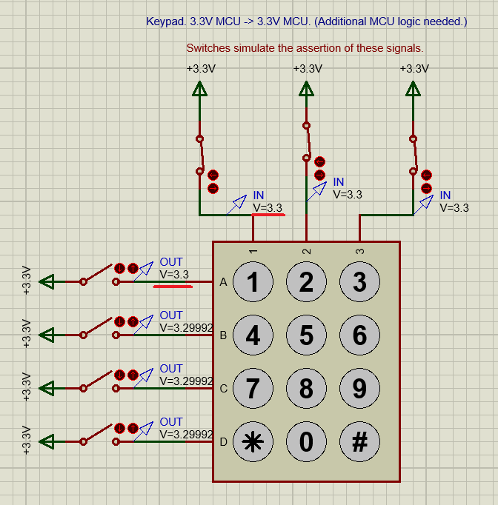

# Comm Terminal

## Summary

|  |  |
| --- | --- |
| Item | Description |
| Device: Purpose | User interface for MCU. Updates params and starts system. |
| Device: Proteus Library component name | Virtual Comm Terminal. |
| Device: Project Operating Range Requirement | Not applicable. |
| Device: Power Connections | None. |
| Device: Electrical signal type properties | Outputs a 5V serial signal. Communicates data on one line and can interface with UART compatible devices. |
| Device: Electrical signal range (voltage, or current, resistance, capacitance or time etc.) | Outputs signals between 0V and 5V. |
| MCU connectivity details | Serial output of comm terminal will connect to serial/UART compatible pin on MCU. |
| Device/MCU interfacing details | 5V output signal is voltage divided to 3.3V for compatibility with MCU. |

## Snips for Part A Schematics and Simulations

# Status LEDs

## Summary

|  |  |
| --- | --- |
| Item | Description |
| Device: Purpose | Display arm state of security system. 3 states: ARMED, DISARMED, ALARM |
| Device: Proteus Library component name | RGBLED-CC. |
| Device: Project Operating Range Requirement | Senses voltage input from MCU. Attains RGB values of 255,0,0; 0,255,0; 0,0,255. |
| Device: Power Connections | One connection to GND, three connections to 3.3V inputs. |
| Device: Electrical signal type properties | The LED receives a 3.3V analog signal. |
| Device: Electrical signal range (voltage, or current, resistance, capacitance or time etc.) | LED forward current is 20mA. Voltage for RED: 1.8V; GREEN: 3.2V; BLUE: 3.2V. Breakdown voltage is 5V. Datasheet not available for RGBLED-CC. |
| MCU connectivity details | All signals source from MCU GPIO pins. Will be one of these devices per door/window. |
| Device/MCU interfacing details | Digital to digital: the input into the device itself is dependent on whichever of the three signals is high. This information is interpreted by the LED as analog, indicating the colour of the LED. |

## Snips for Part A Schematics and Simulations

# Door Lighting

## Summary

|  |  |
| --- | --- |
| Item | Description |
| Device: Purpose | LED used as door lighting when in distance range. |
| Device: Proteus Library component name | ECE298_GEN_LED |
| Device: Project Operating Range Requirement | Senses voltage output from MCU. |
| Device: Power Connections | One connection to GND. One connection to 5V receiver, and one connection to 3.3V for relay operation. |
| Device: Electrical signal type properties | The device accepts a 3.3V digital signal. |
| Device: Electrical signal range (voltage, or current, resistance, capacitance or time etc.) | LED forward voltage is 2.2V, from 10mA to 20mA. Breakdown voltage is 4V. |
| MCU connectivity details | Controlled by the 3.3V digital output pins on the MCU. |
| Device/MCU interfacing details | Digital to digital: MCU digital output is used as-is to flip the 3.3V relay and trigger the LED. |

## Snips for Part A Schematics and Simulations

# LCD Screen

## Summary

|  |  |
| --- | --- |
| Item | Description |
| Device: Purpose | Status display for time, system status, and parameters. |
| Device: Proteus Library component name | Milford 4x20 BKP |
| Device: Project Operating Range Requirement | Screen must have appropriate dimensions to contain time, mode, sensor status. Contains space for 80 characters. |
| Device: Power Connections | Incoming signal input, one connection to GND, one connection to 5V power. |
| Device: Electrical signal type properties | Device receives 5V serial signal input. |
| Device: Electrical signal range (voltage, or current, resistance, capacitance or time etc.) | Device requires constant 5V at 2mA to operate. |
| MCU connectivity details | Device will be connected to MCU serial output pins. |
| Device/MCU interfacing details | Serial to serial: the 3.3V MCU output will need to be pulled up to 5V for LCD operation. |

## Snips for Part A Schematics and Simulations

# Relay

## Summary

|  |  |
| --- | --- |
| Item | Description |
| Device: Purpose | Electric Relay for LED and buzzer use. |
| Device: Proteus Library component name | Relay |
| Device: Project Operating Range Requirement | The device is binary-state, and attains either open or closed position depending on input. |
| Device: Power Connections | Single connection to 3.3V for actuation, single connection to GND. Single connection to applicable power source for relayed device. |
| Device: Electrical signal type properties | The device accepts a digital 3.3V signal for actuation. Resistance is constant 240 Ohms. |
| Device: Electrical signal range (voltage, or current, resistance, capacitance or time etc.) | Signal ranges from 0V to 3.3V. Relayed signal attains variable value depending on object to be powered. |
| MCU connectivity details | Device will be connected, in all cases, to digital MCU output pin(s). |
| Device/MCU interfacing details | Digital to digital: 3.3V MCU output directly routed to relay input. |

# Alarm Buzzer

## Summary

|  |  |
| --- | --- |
| Item | Description |
| Device: Purpose | Alarm buzzer. Signals alarm state. |
| Device: Proteus Library component name | Buzzer |
| Device: Project Operating Range Requirement | Emits a frequency of 500Hz. |
| Device: Power Connections | One connection to GND, one connection to 12V power source. |
| Device: Electrical signal type properties | Device accepts a constant digital signal. |
| Device: Electrical signal range (voltage, or current, resistance, capacitance or time etc.) | Device accepts constant 12V input signal, with a constant resistance of 12 Ohms. Relay accepts 3.3V. |
| MCU connectivity details | Device relay will be connected to MCU digital output pins. Device will be connected to MCU power source. |
| Device/MCU interfacing details | Output from MCU will need to be pulled up to 5V to provide power to buzzer. |

## Snips for Part A Schematics and Simulations

INSTRUCTIONS FOR RUNNING THE PART B SIMULATIONS ARE HERE

The code demonstrates all schematics assuming only one door/window. Status LED is Red in ALARM state, Green in DISARMED state, and blue in ARMED state.

Above the while loop are variables that can be adjusted to change initial conditions. Variable names are self explanatory.

* To test the schematic, arm the system with the password (default is 1111) and the status led should change blue. Simulate opening the door with the top switch and the buzzer should activate as well as changing the status led to flashing red. To disable alarm and go back to disarmed, type in code again.

To test the door light, you can simulate the distance sensor pulse by changing the variable “distanceSensor” to true. This should sufficiently demonstrate everything.